
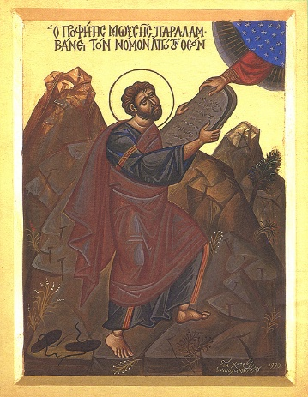
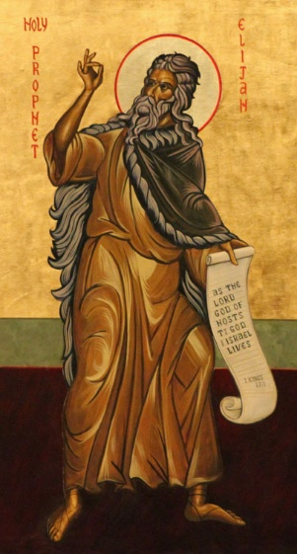

Only John’s Gospel says that John is Not Elijah! Also drops “prepare the way” from Isaiah
Third Sunday of Advent: Jesus is the light. John is a model for the church’s witness to the light.
Light in John’s Gospel
- 1:4-5
- 1:9-11
- 3:19-21
- 8:12
- 9:5
- 11:9-10
- 12:35-36, 46

Compare to:
Matthew 3:1-12
Mark 1:1-8
Luke 3:1-18
All four gospels
- quote Isaiah
- John witnesses to Jesus as the greater one
- John baptizes jesus
ἡ μαρτυρία / marturia = witness
⁶ A man named John was sent from God. ⁷ He came as a witness to testify concerning the light, so that through him everyone would believe in the light. ⁸ He himself wasn’t the light, but his mission was to testify concerning the light.
¹⁹ This is John’s testimony when the Jewish leaders in Jerusalem sent priests and Levites to ask him, “Who are you?”
²⁰ John confessed (he didn’t deny but confessed), “I’m not the Christ.”
²¹ They asked him, “Then who are you? Are you Elijah?”
John said, “I’m not.”
“Are you the prophet?”
John answered, “No.”
²² They asked, “Who are you? We need to give an answer to those who sent us. What do you say about yourself?”
²³ John replied,
“I am a voice crying out in the wilderness,
Make the Lord’s path straight,
just as the prophet Isaiah said.”
²⁴ Those sent by the Pharisees ²⁵ asked, “Why do you baptize if you aren’t the Christ, nor Elijah, nor the prophet?”
²⁶ John answered, “I baptize with water. Someone greater stands among you, whom you don’t recognize. ²⁷ He comes after me, but I’m not worthy to untie his sandal straps.” ²⁸ This encounter took place across the Jordan in Bethany where John was baptizing.

JOhn 1:6-8, 19-28

